Toroidal Solids of Revolution

Definition
# Source: AI Source: Provided by: [Data Path: Persons Table -> ID Column: 1, Name_En Column: Motasem Essam] -> From: [ChatGPT] on [7/25/2026]
A Toroidal Solid of Revolution is a three-dimensional solid generated by rotating a circular plane region around an external coplanar axis.
The resulting solid is called a Torus (plural: Tori).
A toroidal solid has:
- A central axis of revolution.
- A circular generating region.
- A tube-shaped body surrounding the axis.
- A major radius, measured from the revolution axis to the center of the generating circle.
- A minor radius, representing the radius of the generating circle.
- An inner and outer boundary when the torus has a central hole.
Important distinction:
- Rotating a filled circular region generates a solid torus.
- Rotating only the circular boundary generates a toroidal surface.
- The relationship between the major radius and minor radius determines the type of torus.

Geometric Representation
# Source: AI Source: Provided by: [Data Path: Persons Table -> ID Column: 1, Name_En Column: Motasem Essam] -> From: [ChatGPT] on [7/25/2026]
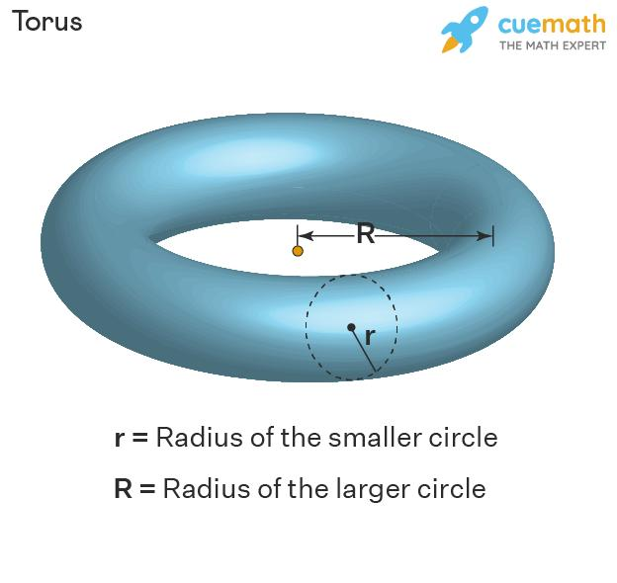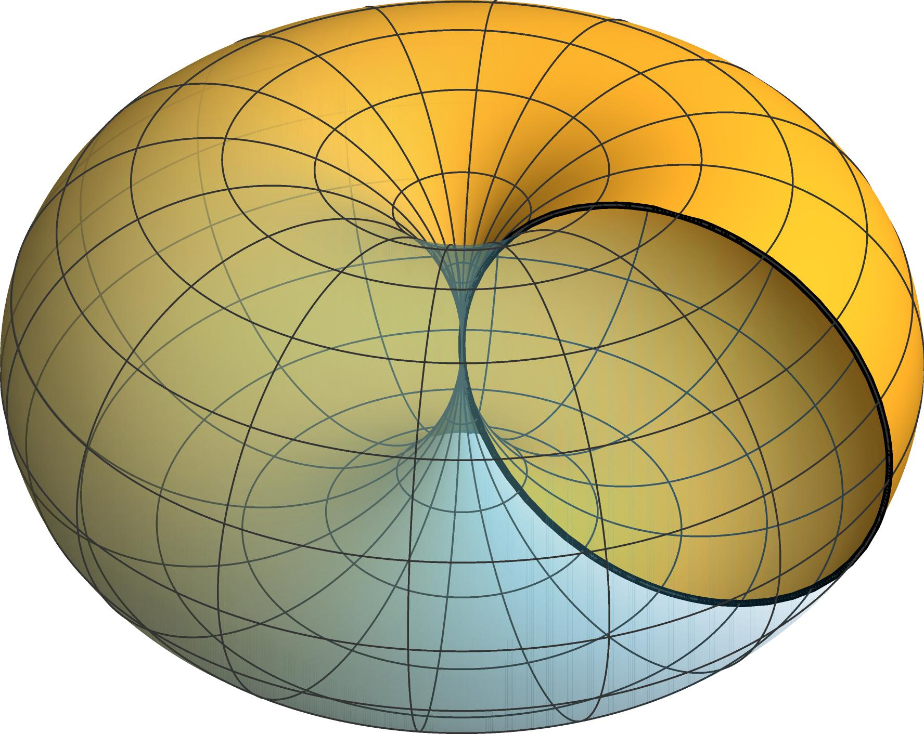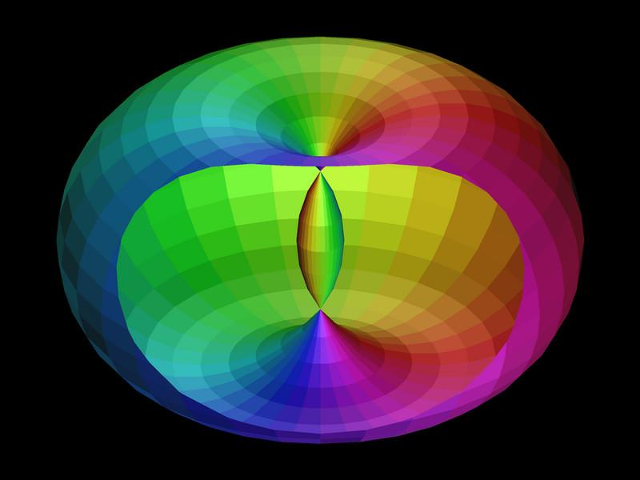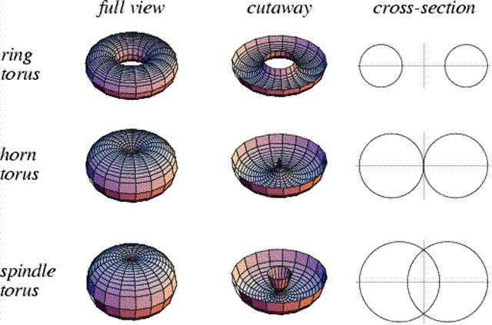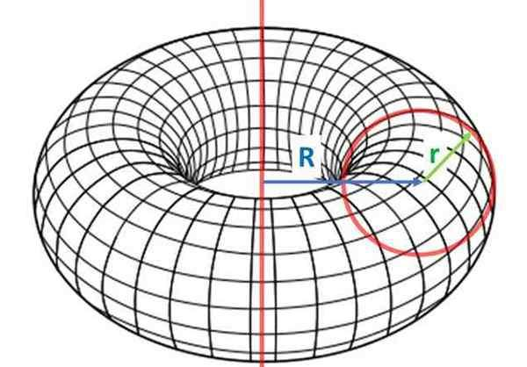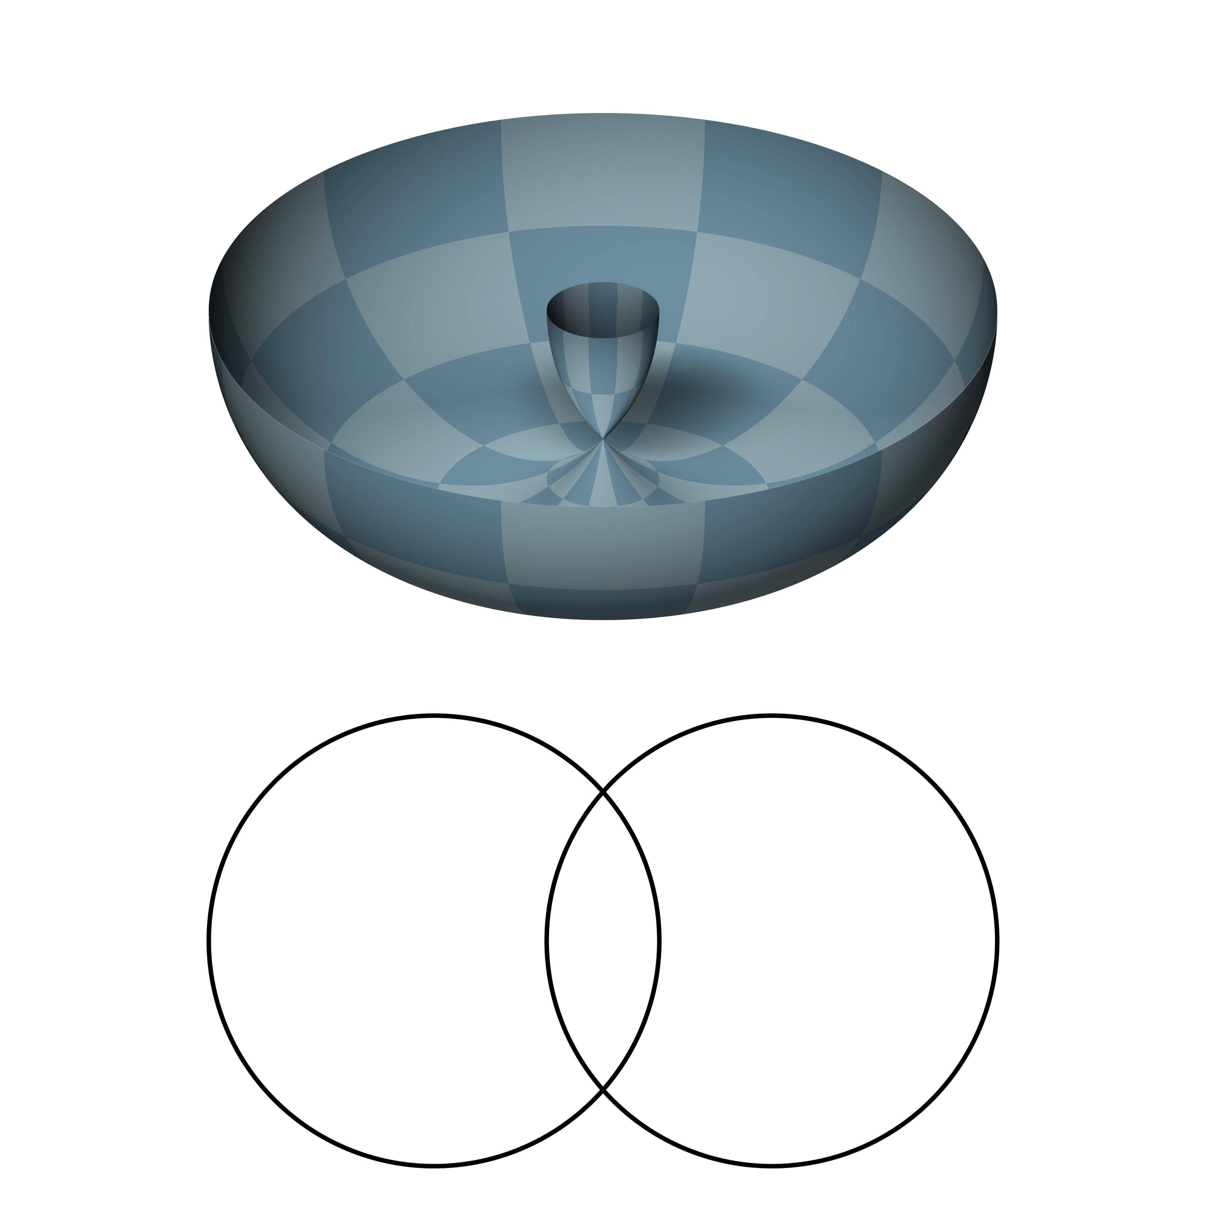

Geometric Structure
# Source: AI Source: Provided by: [Data Path: Persons Table -> ID Column: 1, Name_En Column: Motasem Essam] -> From: [ChatGPT] on [7/25/2026]
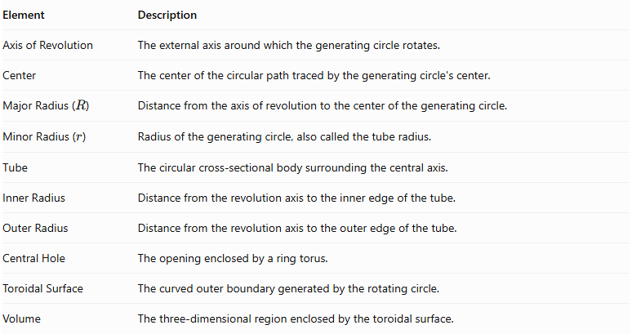
Element | Description
Axis of Revolution | The external axis around which the generating circle rotates.
Center | The center of the circular path traced by the generating circle's center.
Major Radius ($R$) | Distance from the axis of revolution to the center of the generating circle.
Minor Radius ($r$) | Radius of the generating circle, also called the tube radius.
Tube | The circular cross-sectional body surrounding the central axis.
Inner Radius | Distance from the revolution axis to the inner edge of the tube.
Outer Radius | Distance from the revolution axis to the outer edge of the tube.
Central Hole | The opening enclosed by a ring torus.
Toroidal Surface | The curved outer boundary generated by the rotating circle.
Volume | The three-dimensional region enclosed by the toroidal surface.

Types of Toroidal Solids of Revolution
# Source: AI Source: Provided by: [Data Path: Persons Table -> ID Column: 1, Name_En Column: Motasem Essam] -> From: [ChatGPT] on [7/25/2026]
Toroidal solids are classified according to the relationship between their major radius $R$ and minor radius $r$.

Ring Torus
# Source: AI Source: Provided by: [Data Path: Persons Table -> ID Column: 1, Name_En Column: Motasem Essam] -> From: [ChatGPT] on [7/25/2026]
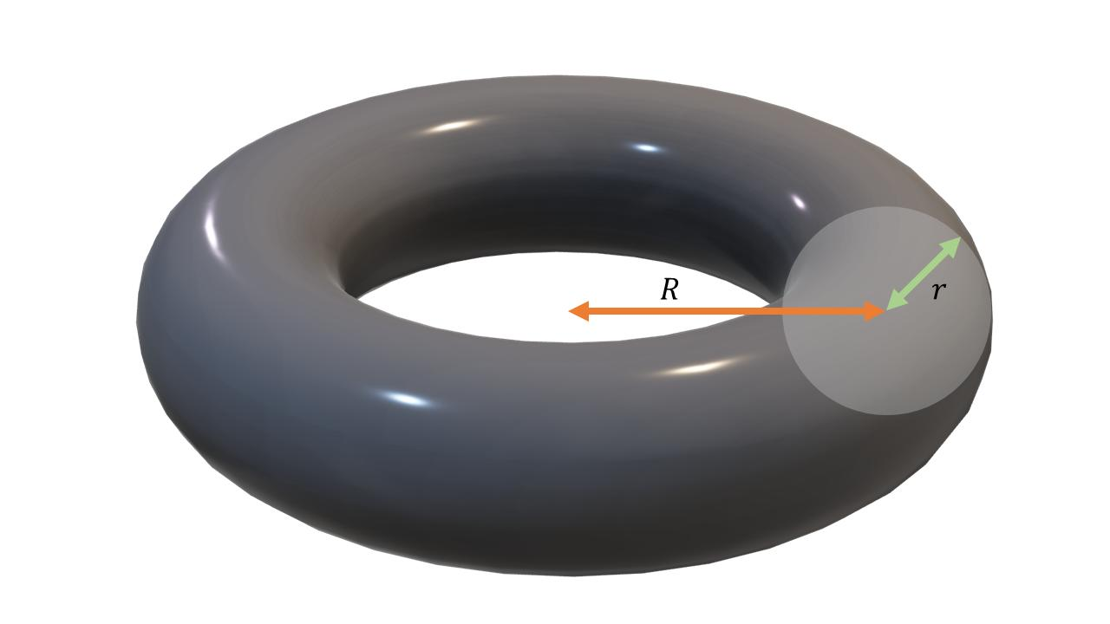
A Ring Torus is generated by rotating a circular region around an external coplanar axis located farther from the circle's center than its radius.
Mathematical condition:
$$\boxed{R>r}$$
Characteristics:
- Has a central hole.
- Has one continuous tube-shaped body.
- Its inner radius is positive.
- Its outer radius is greater than its inner radius.
- It resembles a doughnut or circular ring.
Inner and outer radii:
$$R_{\text{inner}}=R-r$$
$$R_{\text{outer}}=R+r$$

Horn Torus
# Source: AI Source: Provided by: [Data Path: Persons Table -> ID Column: 1, Name_En Column: Motasem Essam] -> From: [ChatGPT] on [7/25/2026]
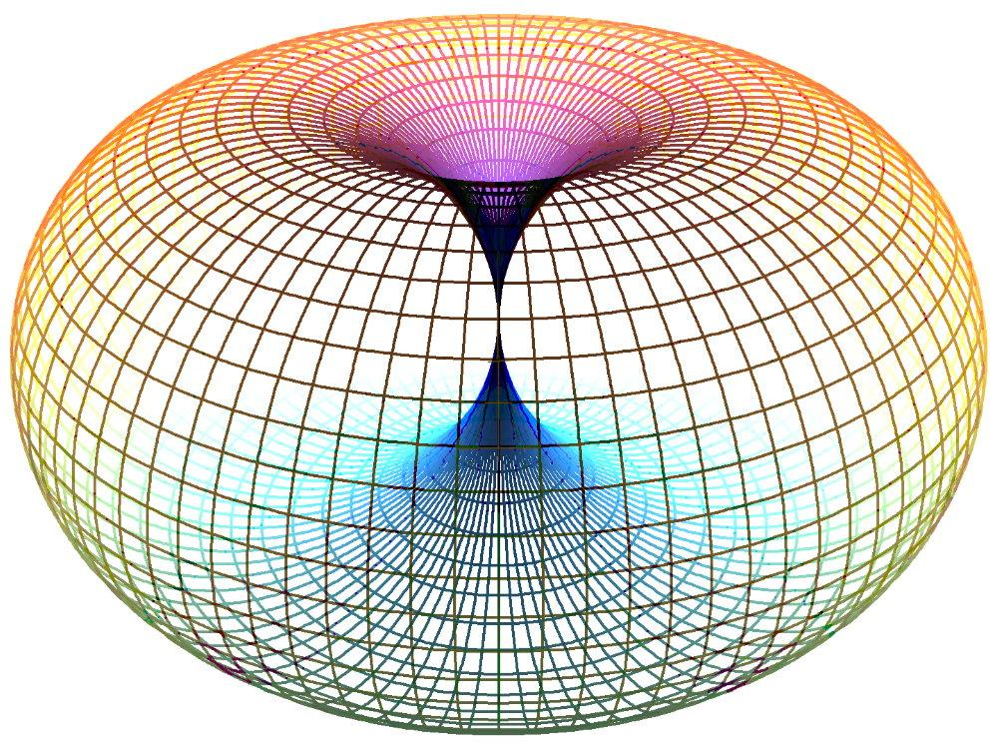
A Horn Torus is generated by rotating a circular region around an external coplanar axis tangent to the circle.
Mathematical condition:
$$\boxed{R=r}$$
Characteristics:
- The central hole closes at one point.
- The inner radius becomes zero.
- The surface touches itself at a single point on the axis of revolution.
- It has a characteristic horn-like shape.
- It represents the boundary case between a ring torus and a spindle torus.

Spindle Torus
# Source: AI Source: Provided by: [Data Path: Persons Table -> ID Column: 1, Name_En Column: Motasem Essam] -> From: [ChatGPT] on [7/25/2026]
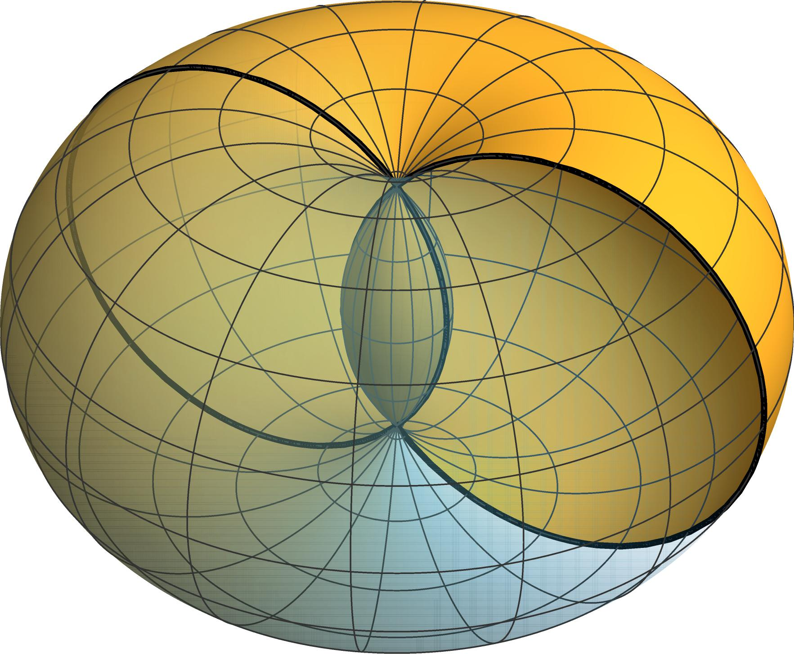
A Spindle Torus is generated by rotating a circular region around an external coplanar axis located closer to the circle's center than its radius.
Mathematical condition:
$$\boxed{R<r}$$
Characteristics:
- Has no open central hole.
- The generated surface intersects itself.
- Has pointed or pinched regions along the axis of revolution.
- Its geometry differs from the regular ring torus.
- The surface contains self-intersecting regions.
Important: The spindle torus is a self-intersecting parametrized surface. Its enclosed volume and surface area require a precise convention about whether the intended region is the union of the swept disks or a particular surface-bounded component.

Mathematical Representation

Standard Parametric Equations
# Source: AI Source: Provided by: [Data Path: Persons Table -> ID Column: 1, Name_En Column: Motasem Essam] -> From: [ChatGPT] on [7/25/2026]
A torus centered around the $z$-axis can be represented parametrically by:
$$x=(R+rcosv)cosu$$
$$y=(R+rcosv)sinu$$
$$z=rsinv$$
Where:
- $R$ = major radius.
- $r$ = minor radius.
- $u$ = angle around the main axis.
- $v$ = angle around the circular tube.
Both angles vary from $0$ to $2π$.

Cartesian Equation
# Source: AI Source: Provided by: [Data Path: Persons Table -> ID Column: 1, Name_En Column: Motasem Essam] -> From: [ChatGPT] on [7/25/2026]
The implicit equation of the toroidal surface is:
$$\boxed{{\left(\sqrt{x^{2}+y^{2}}-R\right)}^{2}+z^{2}=r^{2}}$$
An equivalent polynomial form is:
$$\boxed{(x^{2}+y^{2}+z^{2}+R^{2}-r^{2})^{2}=4R^{2}(x^{2}+y^{2})}$$
These equations describe the toroidal surface, not the entire filled solid.

Volume of a Ring Torus
# Source: AI Source: Provided by: [Data Path: Persons Table -> ID Column: 1, Name_En Column: Motasem Essam] -> From: [ChatGPT] on [7/25/2026]
For a ring torus:
$$\boxed{V=2π^{2}{Rr}^{2}}$$
This formula can be obtained using Pappus's centroid theorem.
The generating circular region has area:
$$A=πr^{2}$$
Its center travels a circular path of circumference:
$$C=2πR$$
Therefore:
$$V=A×C$$
$$V=πr^{2}(2πR)$$
$$V=2π^{2}{Rr}^{2}$$

Surface Area of a Ring Torus
# Source: AI Source: Provided by: [Data Path: Persons Table -> ID Column: 1, Name_En Column: Motasem Essam] -> From: [ChatGPT] on [7/25/2026]
The surface area is:
$$\boxed{S=4π^{2}Rr}$$
This is the area of the surface generated by rotating the circular boundary.

Horn Torus Formulas
# Source: AI Source: Provided by: [Data Path: Persons Table -> ID Column: 1, Name_En Column: Motasem Essam] -> From: [ChatGPT] on [7/25/2026]
For a horn torus, $R=r$.
Volume:
$$V=2π^{2}r^{3}$$
Surface area:
$$S=4π^{2}r^{2}$$
These are the limiting formulas for the horn torus.

Mathematical Properties
# Source: AI Source: Provided by: [Data Path: Persons Table -> ID Column: 1, Name_En Column: Motasem Essam] -> From: [ChatGPT] on [7/25/2026]
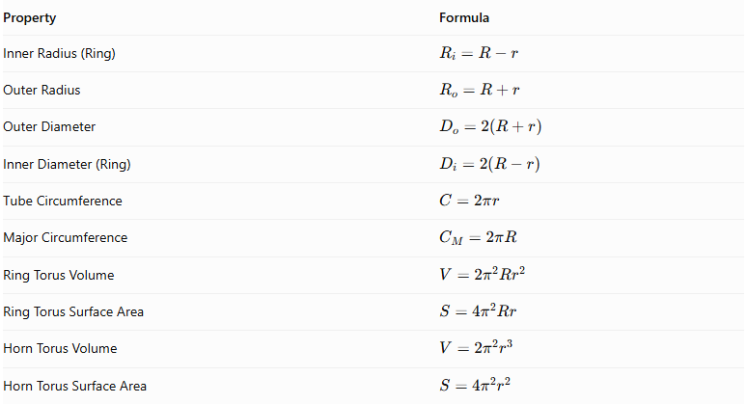
Property | Formula
Inner Radius (Ring) | $$R_{i}=R-r$$
Outer Radius | $$R_{o}=R+r$$
Outer Diameter | $$D_{o}=2(R+r)$$
Inner Diameter (Ring) | $$D_{i}=2(R-r)$$
Tube Circumference | $$C=2πr$$
Major Circumference | $$C_{M}=2πR$$
Ring Torus Volume | $$V=2π^{2}{Rr}^{2}$$
Ring Torus Surface Area | $$S=4π^{2}Rr$$
Horn Torus Volume | $$V=2π^{2}r^{3}$$
Horn Torus Surface Area | $$S=4π^{2}r^{2}$$
Note: The standard volume and surface-area formulas above apply to the ring torus and their horn-torus limiting case. They should not be applied indiscriminately to the self-intersecting spindle torus.

Cross-Sections
# Source: AI Source: Provided by: [Data Path: Persons Table -> ID Column: 1, Name_En Column: Motasem Essam] -> From: [ChatGPT] on [7/25/2026]
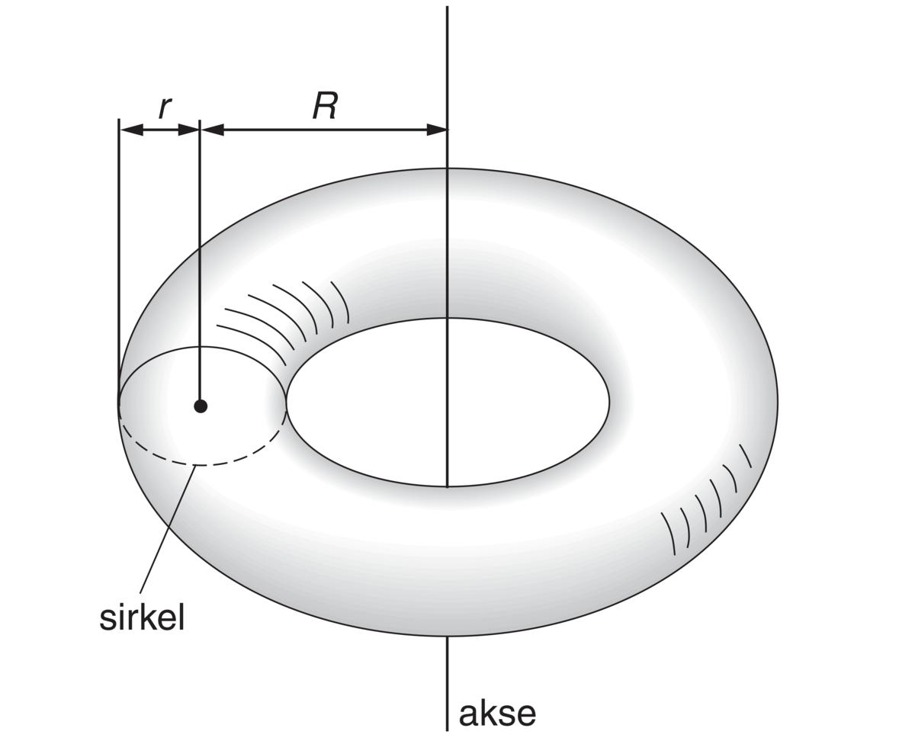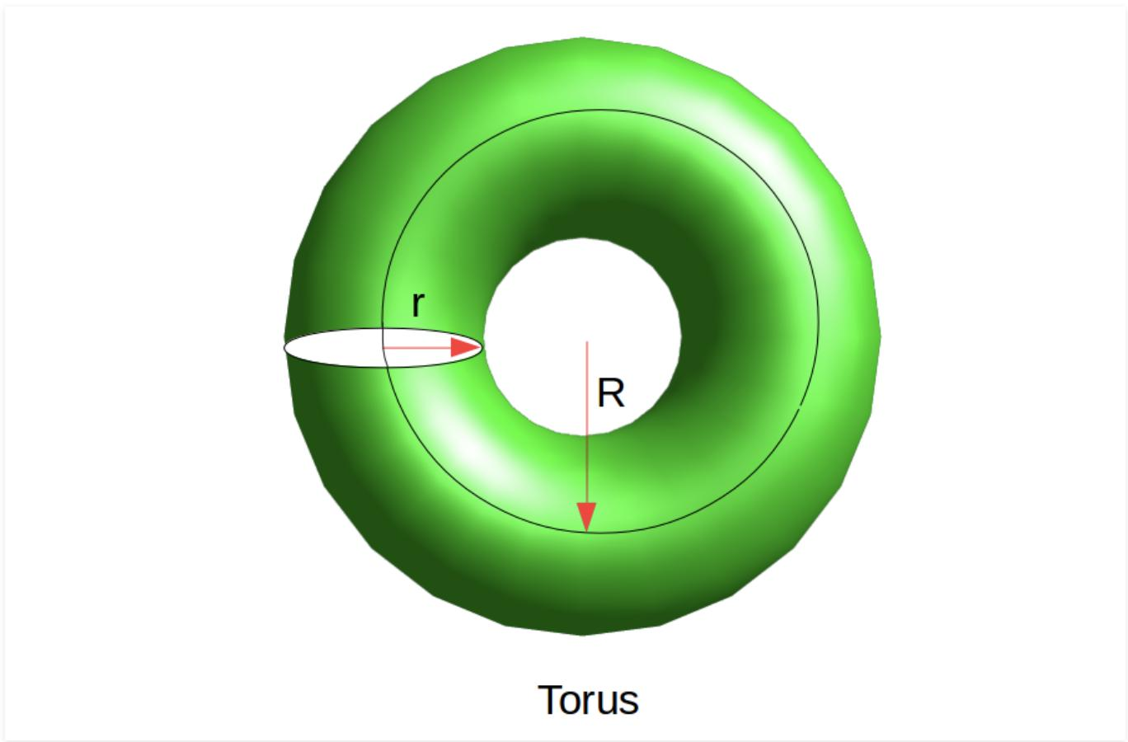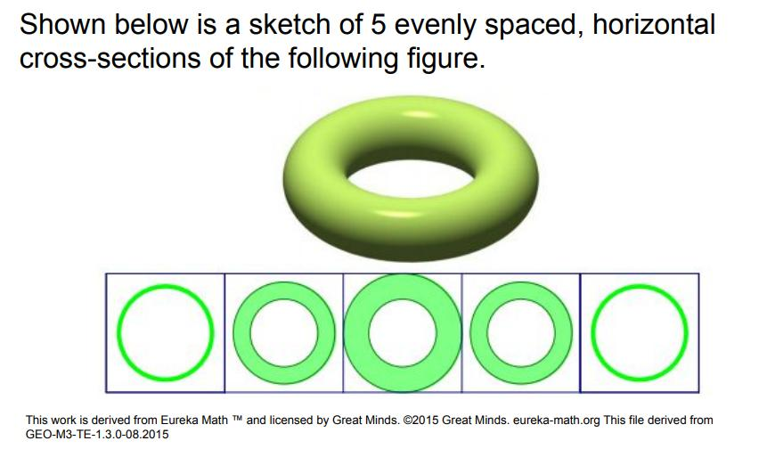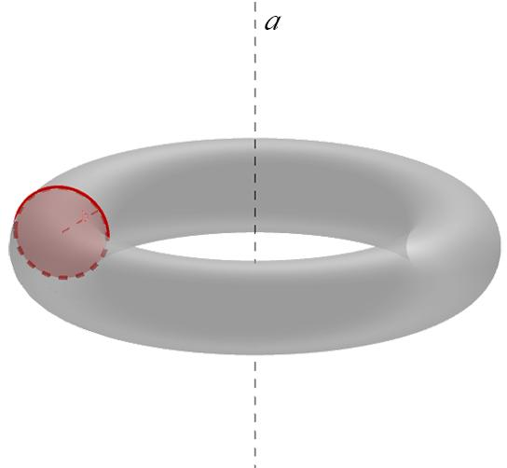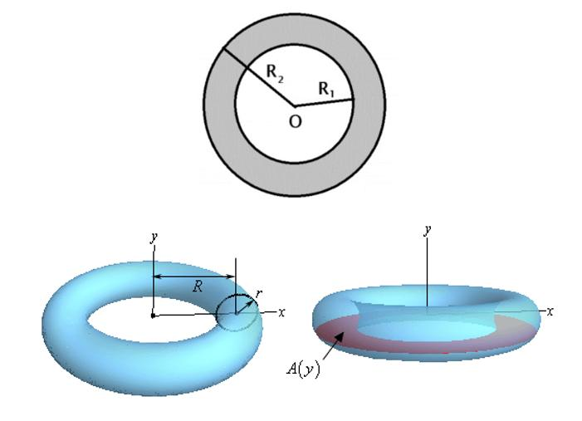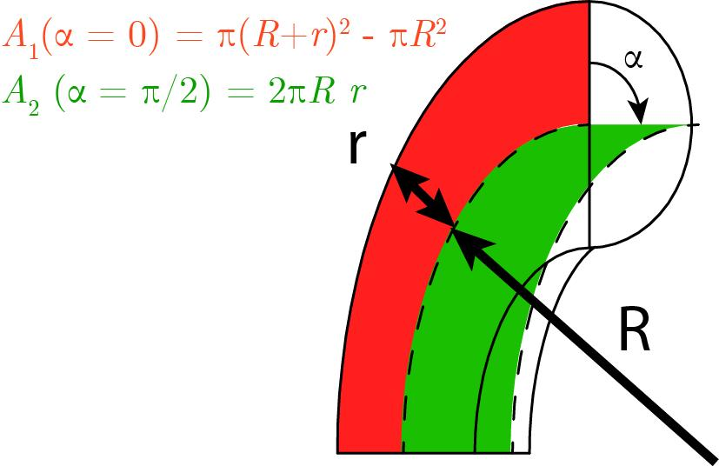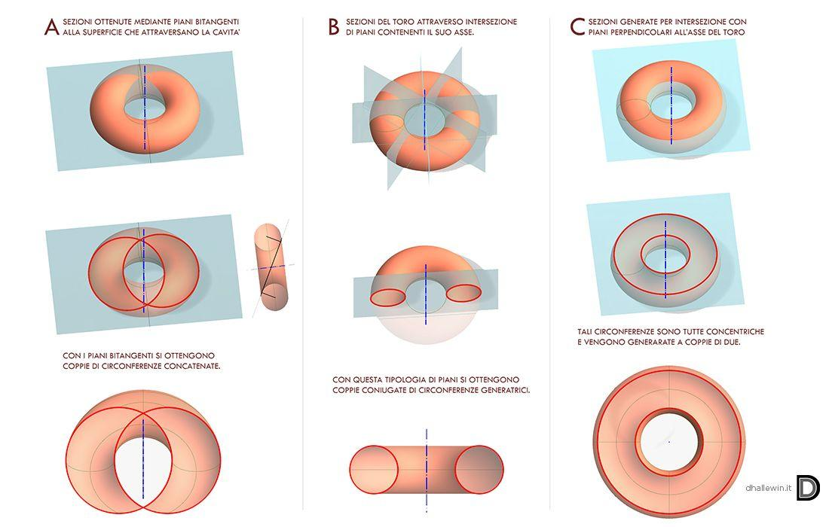
The cross-section of a toroidal solid depends on the orientation and position of the cutting plane.

Axial Cross-Section
# Source: AI Source: Provided by: [Data Path: Persons Table -> ID Column: 1, Name_En Column: Motasem Essam] -> From: [ChatGPT] on [7/25/2026]
A plane passing through the axis of revolution intersects a ring torus in two circular regions (disks), one on each side of the axis.

Equatorial Cross-Section
# Source: AI Source: Provided by: [Data Path: Persons Table -> ID Column: 1, Name_En Column: Motasem Essam] -> From: [ChatGPT] on [7/25/2026]
A plane perpendicular to the axis of revolution and passing through the center produces an annular region.
Its inner radius is:
$$R-r$$
Its outer radius is:
$$R+r$$
The area of this annular cross-section is:
$$A=π[(R+r)^{2}-(R-r)^{2}]$$
Simplifying:
$$\boxed{A=4πRr}$$

Parallel Cross-Sections
# Source: AI Source: Provided by: [Data Path: Persons Table -> ID Column: 1, Name_En Column: Motasem Essam] -> From: [ChatGPT] on [7/25/2026]
Parallel planes perpendicular to the axis produce circular or annular regions, depending on their position.
For a ring torus, the cross-sectional boundaries satisfy:
$$(ρ-R)^{2}+z^{2}=r^{2}$$
where:
$$ρ=\sqrt{x^{2}+y^{2}}$$

Applications
# Source: AI Source: Provided by: [Data Path: Persons Table -> ID Column: 1, Name_En Column: Motasem Essam] -> From: [ChatGPT] on [7/25/2026]
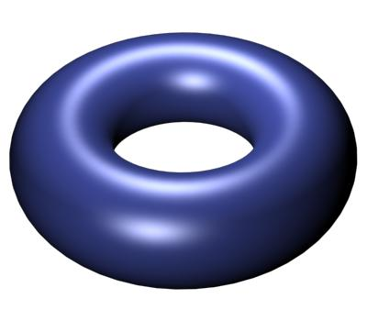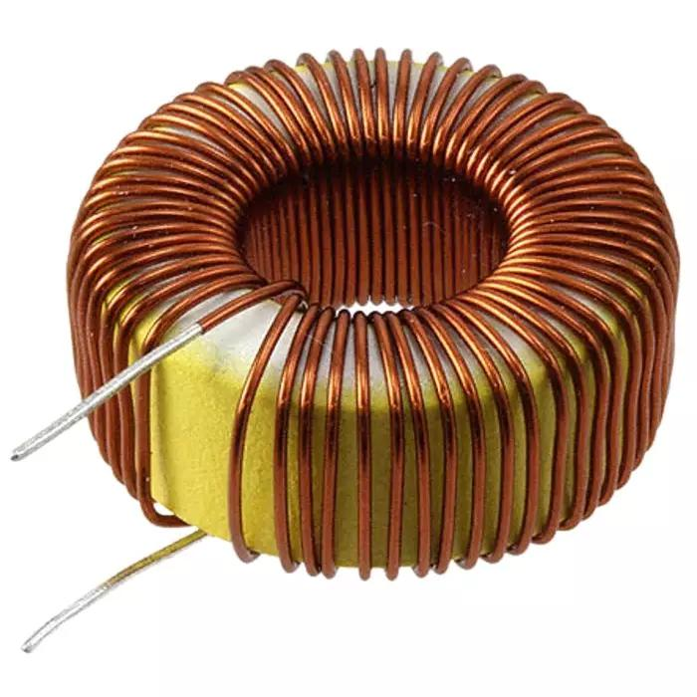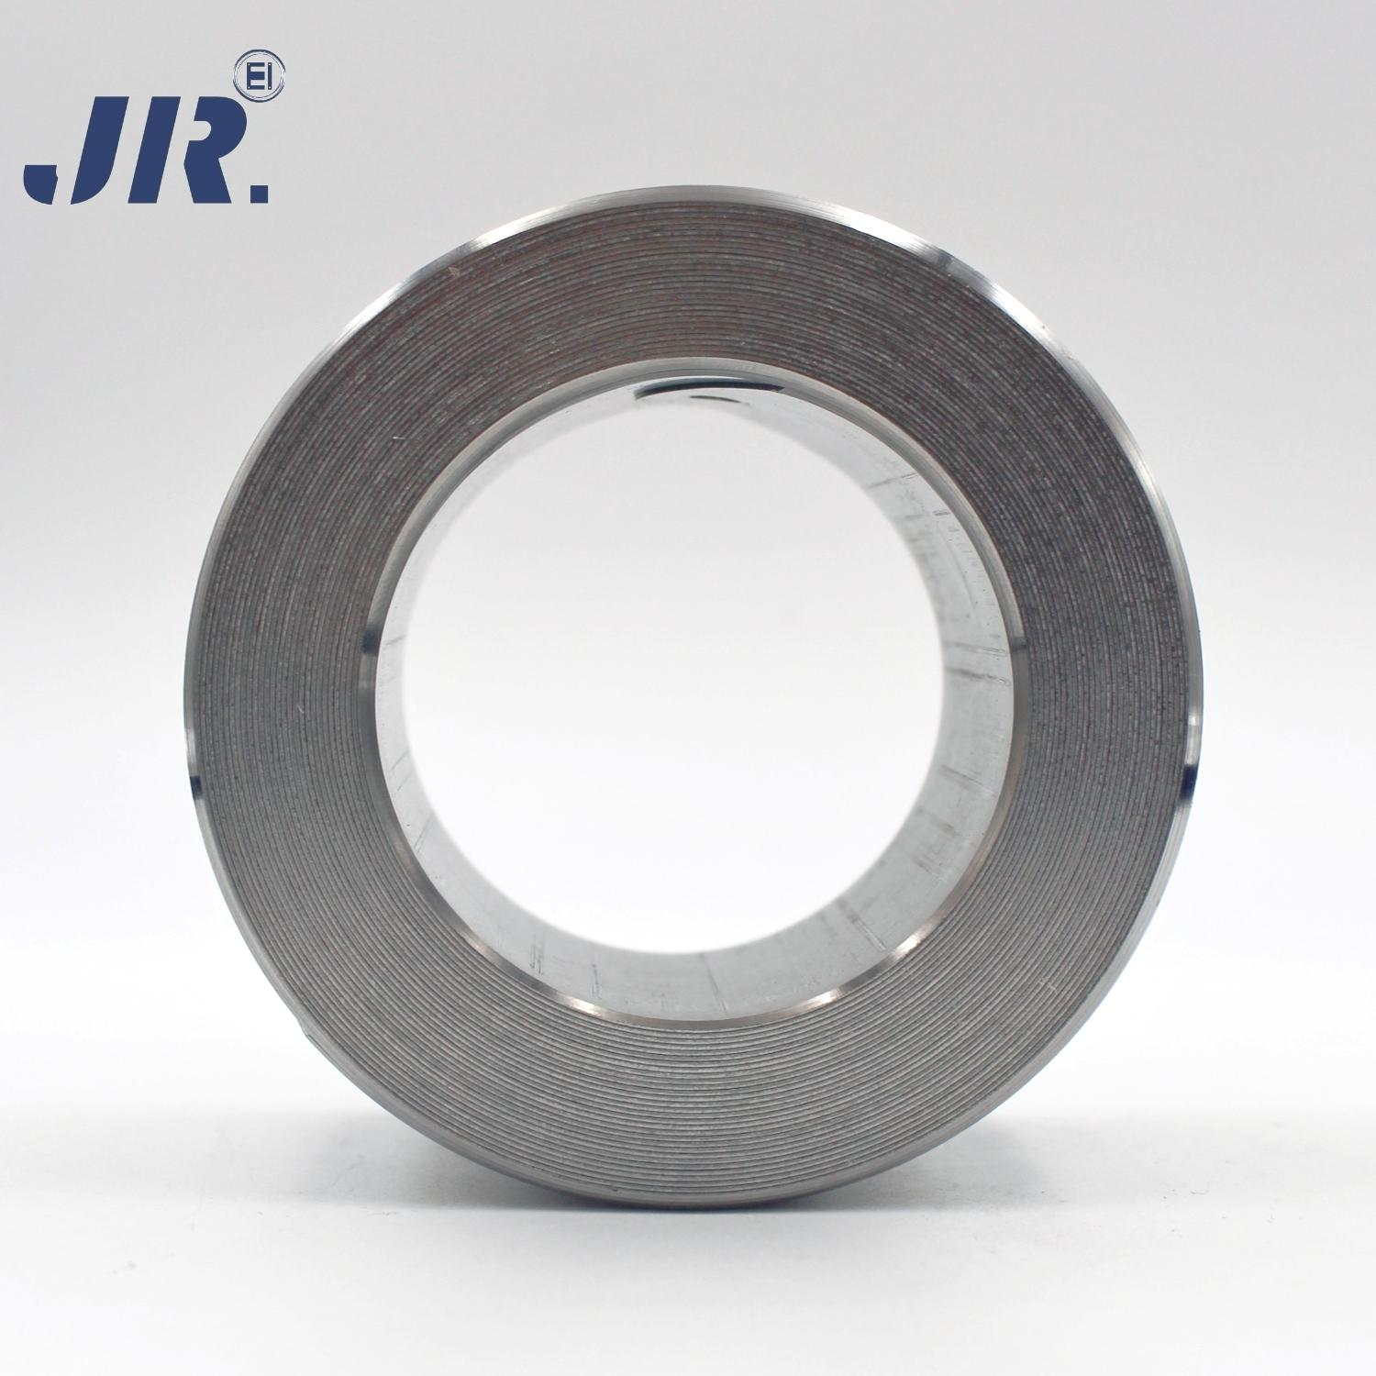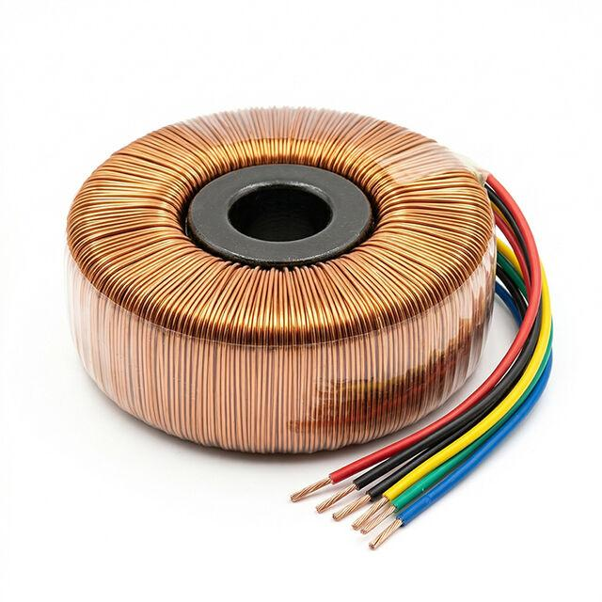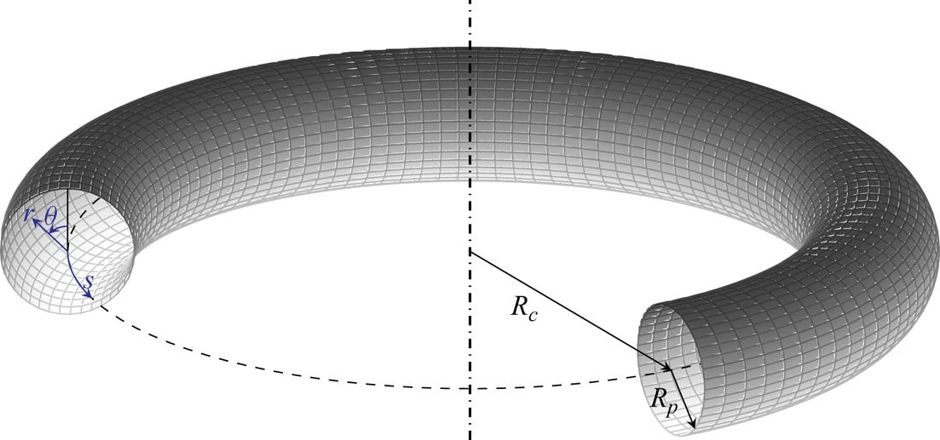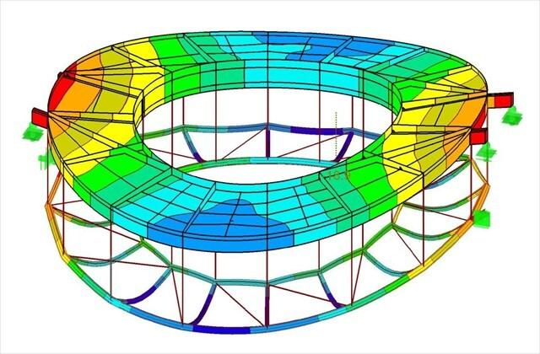
- Electrical Engineering: Toroidal transformer cores and inductors.
- Electromagnetism: Toroidal coils and magnetic field systems.
- Mechanical Engineering: Toroidal seals, rings, and specialized components.
- Fluid Systems: Toroidal pipes and circulation systems.
- Industrial Design: Ring-shaped containers and mechanical components.
- Mathematics: Modeling rotational symmetry and three-dimensional surfaces.

Comparison of Toroidal Types
# Source: AI Source: Provided by: [Data Path: Persons Table -> ID Column: 1, Name_En Column: Motasem Essam] -> From: [ChatGPT] on [7/25/2026]
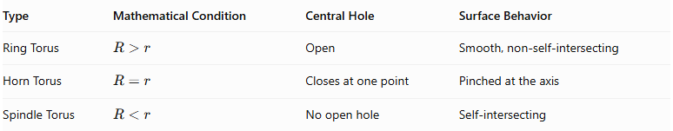
Type | Mathematical Condition | Central Hole | Surface Behavior
Ring Torus | $$R>r$$ | Open | Smooth, non-self-intersecting
Horn Torus | $$R=r$$ | Closes at one point | Pinched at the axis
Spindle Torus | $$R<r$$ | No open hole | Self-intersecting
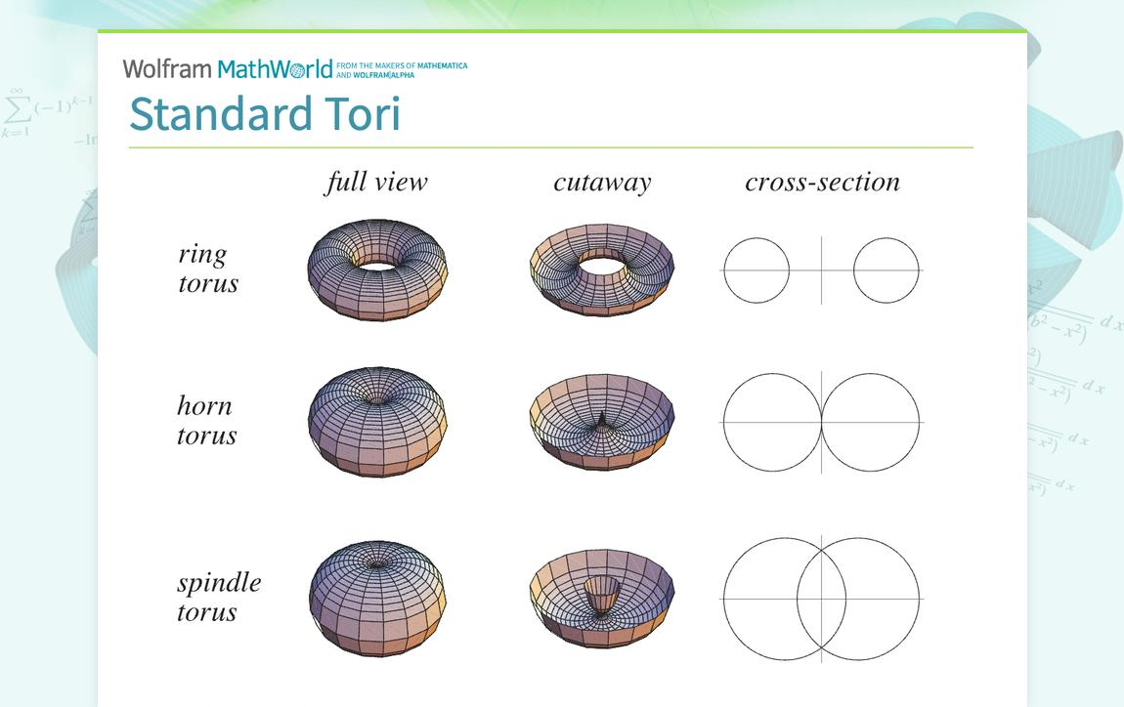

Comparison with Other Solids of Revolution
# Source: AI Source: Provided by: [Data Path: Persons Table -> ID Column: 1, Name_En Column: Motasem Essam] -> From: [ChatGPT] on [7/25/2026]
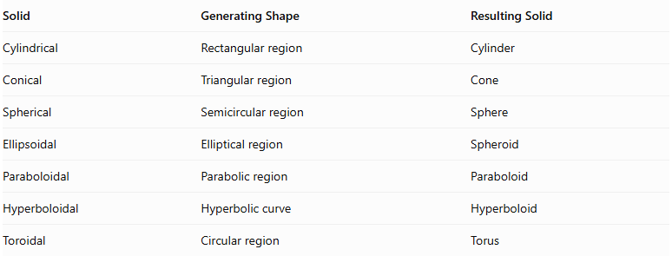
Solid | Generating Shape | Resulting Solid
Cylindrical | Rectangular region | Cylinder
Conical | Triangular region | Cone
Spherical | Semicircular region | Sphere
Ellipsoidal | Elliptical region | Spheroid
Paraboloidal | Parabolic region | Paraboloid
Hyperboloidal | Hyperbolic curve | Hyperboloid
Toroidal | Circular region | Torus

Main Classification
# Source: AI Source: Provided by: [Data Path: Persons Table -> ID Column: 1, Name_En Column: Motasem Essam] -> From: [ChatGPT] on [7/25/2026]
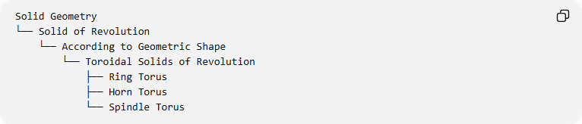
Solid Geometry
└── Solid of Revolution
└── According to Geometric Shape
└── Toroidal Solids of Revolution
├── Ring Torus
├── Horn Torus
└── Spindle Torus

Key Points
# Source: AI Source: Provided by: [Data Path: Persons Table -> ID Column: 1, Name_En Column: Motasem Essam] -> From: [ChatGPT] on [7/25/2026]
- A toroidal solid is generated by rotating a circular region around a coplanar axis.
- The major radius measures the distance from the axis of revolution to the center of the generating circle.
- The minor radius is the radius of the generating circle.
- A ring torus has an open central hole.
- A horn torus has a central hole that closes at one point.
- A spindle torus has a self-intersecting surface.
- The ring torus volume is $2π^{2}{Rr}^{2}$.
- The ring torus surface area is $4π^{2}Rr$.
- A toroidal surface and a solid torus are different geometric objects.

Important Geometric Distinction
# Source: AI Source: Provided by: [Data Path: Persons Table -> ID Column: 1, Name_En Column: Motasem Essam] -> From: [ChatGPT] on [7/25/2026]
Torus vs. Solid Torus vs. Toroidal Surface
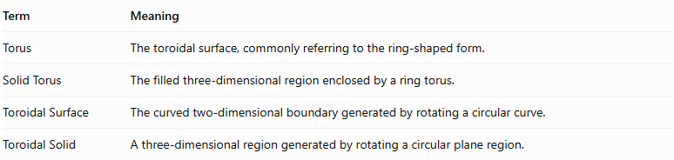
Term | Meaning
Torus | The toroidal surface, commonly referring to the ring-shaped form.
Solid Torus | The filled three-dimensional region enclosed by a ring torus.
Toroidal Surface | The curved two-dimensional boundary generated by rotating a circular curve.
Toroidal Solid | A three-dimensional region generated by rotating a circular plane region.
The position of the axis relative to the generating disk determines the geometry:
- $R>r$: The axis does not intersect the disk, producing a ring torus.
- $R=r$: The axis is tangent to the disk, producing a horn torus.
- $R<r$: The axis passes through the disk, producing a spindle torus.

Conclusion
# Source: AI Source: Provided by: [Data Path: Persons Table -> ID Column: 1, Name_En Column: Motasem Essam] -> From: [ChatGPT] on [7/25/2026]
Toroidal solids of revolution are three-dimensional geometric forms generated by rotating circular regions around coplanar axes. Their classification depends on the relationship between the major radius and minor radius, producing three principal forms: the ring torus, horn torus, and spindle torus.
The ring torus is the standard non-self-intersecting form, characterized by a central hole and a continuous tube-shaped body. The horn torus represents the limiting form in which the central hole closes at one point, while the spindle torus has a self-intersecting surface.
Toroidal geometry is important in mathematics, electrical engineering, mechanical engineering, and industrial design because of its rotational symmetry and distinctive geometric properties.

